**The Consulate General of Japan in Detroit**

**2019 Michigan Japanese Language Speech Contest**

**Contest Rules and Guidelines for High School Speech Practice**

**Speech Contest Specifics**

* **Theme:** Passion (情熱)
* **Topic:** Topics are open to the extent they are not offensive or inappropriate.
* **Time Limit:** Three minute maximum.
* **Presentation:** Performances of any kind (storytelling, musical, recitation, etc.) are not permitted. Limited use of note cards *for reference only* is permitted.
* **Judging:** There is no judging for this category.
* Applicants may not apply to more than one speech contest category.
* Native Japanese speakers, or those with a native-speaking parent, are ineligible.
* Candidates having stayed in Japan more than one year total are not eligible.
* There is a possibility that the number of participants may be limited.
* **Speeches must be original and written by the students.** Any appearing to have had too much input from teachers or native speakers may be excluded. *Please keep in mind that this is an opportunity for the students to show what they have learned.*
* Submit one copy of your Japanese speech in Microsoft Word. **Make sure to include your full name in Japanese (カタカナ) and English**.
* All submissions must be done by email and be sent by 5 PM on January 16th.

**Checklist (total sent file size must be under 10 mbs)**

* Entry Form in Word document
* Typed Japanese speech in Word document

**Note: If your application is submitted successfully, you will receive a reply by the next business day.**

**The Consulate General of Japan in Detroit**

**2019 Michigan Japanese Language Speech Contest**

**Entry Form High School Speech Practice**

|  |  |  |  |  |  |  |
| --- | --- | --- | --- | --- | --- | --- |
|  |  |  | | |  |  |
|  |  |  | | |  |  |
| Last Name |  | First Name | | |  | Name in Katakana（カタカナ） |
|  | | | | | | |
| High School Practice |  | Freshman Sophomore  Junior Senior | | |  |  |
| Category |  | Year *(circle one)* | | |  | Contact Email Address |
|  | | | | | | |
|  |  |  | | |  |  |
| School Attending |  | Current Course (e.g. Japanese 2, JPN350) | | |  | Japanese Instructor |
|  | | | | | | |
|  |  |  | | |  |  |
| Your Native Language |  | Parents’ Native Languages | | |  | Prior Speech Contest Participation |
|  | | | | | | |
|  | | |  |  | | |
| Japanese Courses Completed | | |  | Japan Visits, Purpose & Length of Stay | | |
|  | | | | | | |
|  | | |  |  | | |
| Name of Speech in English | | |  | Name of Speech in Japanese | | |
|  | | | | | | |

**Please submit by 5PM on January 16th:**

Entry Form – (Word file)

Japanese Speech Text – (*Word file*)

*Total Submission Must be Under 10 MB*

**Email Address**

Digital transmissions of entry forms and texts

may be sent to adam.wolf@dt.mofa.go.jp.

*Please limit files to .doc and .docx*

*formats as stated above.*

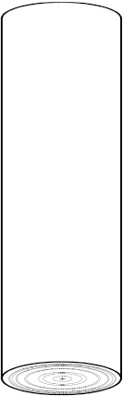

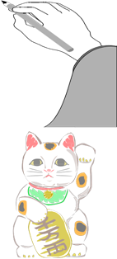

2019ミシガン

日本語弁論大会



**2019 Michigan Japanese Language Speech Contest**

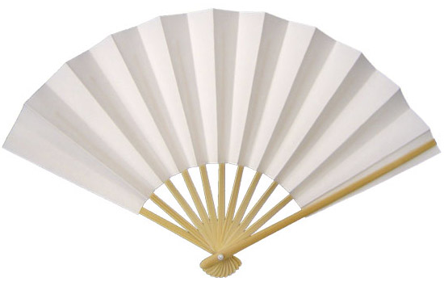

If you **love** Japanese, a real challenge, and

the chance to win prizes, join us for the

**Michigan 2019 Japanese Language Speech Contest**.

Applications and information are available through your language instructor or online at

<http://www.detroit.us.emb-japan.go.jp/itprtop_en/index.html.>

The event will be on

**Sunday, February 17th, 2019**

from 1:00PM

Deadline for Entries

**at the Novi Civic Center**

January 16, 2019

**Consulate-General**

**of Japan in Detroit**

**The Consulate General of Japan in Detroit**

**2019 Michigan Japanese Language Speech Contest**

*The Consulate General of Japan in Detroit is pleased to announce that applications are now being accepted for the 2019 Michigan Japanese Language Speech Contest. The competition, now in its 24nd consecutive year, was established to encourage students to experience the power of foreign language communication, increase the desire for Japanese language students to improve their skills and understanding, and strengthen the bond of friendship between the United States and Japan through their efforts. We welcome your participation.*

**DATE** Sunday, February 17, 2019  
 from 1:00PM

**LOCATION** Novi Civic Center

45175 W 10 Mile Rd, Novi, MI 48375

**CATEGORIES** High School Speech Practice

High School Contestant  
 University Contestant

**DEADLINE** **5PM – January 16, 2019 (Wed.)**

**(If your application is submitted successfully, you will**

**Receive a reply by the next business day)**

Entry form in word document and word document of Japanese speech Total Submission Size Must Be Under 10 MB **Don’t forget your name in English and Japanese (カタカナ)**

**IN COOPERATION WITH** City of Novi

**FORMS** Additional forms and criteria may be

downloaded from our website.

*For questions please contact Mr. Adam Wolf at the Consulate General office   
(313-567-0120 ext. 226, or Adam.wolf@dt.mofa.go.jp)*