**The Consulate General of Japan in Detroit**

**2019 Michigan Japanese Language Speech Contest**

**Contest Rules and Guidelines for High School Contestant**

**Speech Contest Specifics**

* **Theme:** Passion (情熱)
* **Topic:** Topics are open to the extent they are not offensive or inappropriate.
* **Time Limit:** Three minute maximum. Penalty points may be assessed for exceeding time limits.
* **Presentation:** Performances of any kind (storytelling, musical, recitation, etc.) are not permitted. Limited use of note cards *for reference only* is permitted.
* **Judging:** Scoring will be based on language (pronunciation, accuracy); presentation (memorization, intonation, clarity); and content.
* **Award:** First, Second and Third Place winners will be selected from each category.
* Applicants may not apply to more than one speech contest category.
* Native Japanese speakers, or those with a native-speaking parent, are ineligible.
* Candidates having stayed in Japan more than one year total are not eligible.
* Applications will be screened and the number of participants may be limited.
* **Speeches must be original and written by the students.** Any appearing to have had too much input from teachers or native speakers may be excluded. *Please keep in mind that this is an opportunity for the students to show what they have learned.*
* Submit two typed copies of the speech in Microsoft Word documents. One should be in Japanese and one should be in English. Include an audio recording of the speech as an MP3 file. **Make sure to include your full name in Japanese (カタカナ) and English**.
* First place winners of a prior speech contest are not eligible to enter in the same category.
* All submissions must be done by email and be sent by 5 PM on January 16th.
* **TIP** Translated scripts can seem unnatural. Try writing the original in Japanese for a more authentic sounding presentation and accurate demonstration of your ability. Emphasis should be placed on delivery and language that is natural and expressive, utilizing culturally appropriate verbal/non-verbal language and avoiding superficial or stereotypical behavior.

**Checklist (total sent file size must be under 10 mbs)**

* Entry Form in Word document
* Typed English translation of speech in Word document
* Typed Japanese speech in Word document
* Audio recording of speech in MP3 format

**Note: If your application is submitted successfully, you will receive a reply by the next business day.**

**The Consulate General of Japan in Detroit**

**2019 Michigan Japanese Language Speech Contest**

**Entry Form High School Contestant**

|  |  |  |  |  |  |  |
| --- | --- | --- | --- | --- | --- | --- |
|  |  |  | | |  |  |
|  |  |  | | |  |  |
| Last Name |  | First Name | | |  | Name in Katakana（カタカナ） |
|  | | | | | | |
| High School Contestant |  | Freshman Sophomore  Junior Senior | | |  |  |
| Category |  | Year *(circle one)* | | |  | Contact Email Address |
|  | | | | | | |
|  |  |  | | |  |  |
| School Attending |  | Current Course (e.g. Japanese 2, JPN350) | | |  | Japanese Instructor |
|  | | | | | | |
|  |  |  | | |  |  |
| Your Native Language |  | Parents’ Native Languages | | |  | Prior Speech Contest Participation |
|  | | | | | | |
|  | | |  |  | | |
| Japanese Courses Completed | | |  | Japan Visits, Purpose & Length of Stay | | |
|  | | | | | | |
|  | | |  |  | | |
| Name of Speech in English | | |  | Name of Speech in Japanese | | |
|  | | | | | | |

**Please submit by 5PM on January 16th:**

Entry Form (Word file)

Japanese Speech Text (*Word file*)

English Translation *(Word file)*

Audio of speech *(.MP3 file)*

*Total Submission Must be Under 10 MB*

**Email Address**

Digital transmissions of entry forms, texts,

translations, and audio may be sent

to adam.wolf@dt.mofa.go.jp.

*Please limit files to .doc, .docx, and .mp3*

*formats as stated above.*

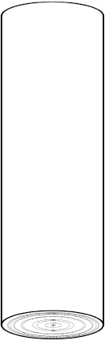

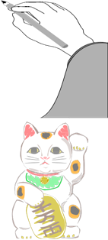

2019ミシガン

日本語弁論大会



**2019 Michigan Japanese Language Speech Contest**

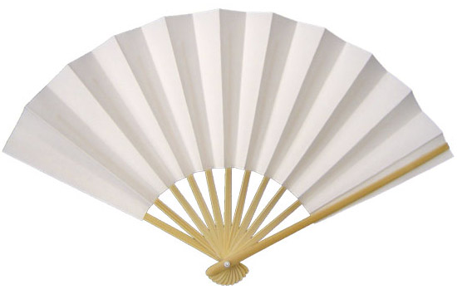

If you **love** Japanese, a real challenge, and

the chance to win prizes, join us for the

**Michigan 2019 Japanese Language Speech Contest**.

Applications and information are available through your language instructor or online at

<http://www.detroit.us.emb-japan.go.jp/itprtop_en/index.html.>

The event will be on

**Sunday, February 17th, 2019**

from 1:00PM

Deadline for Entries

**at the Novi Civic Center**

January 16, 2019

**Consulate-General**

**of Japan in Detroit**

**The Consulate General of Japan in Detroit**

**2019 Michigan Japanese Language Speech Contest**

*The Consulate General of Japan in Detroit is pleased to announce that applications are now being accepted for the 2019 Michigan Japanese Language Speech Contest. The competition, now in its 24nd consecutive year, was established to encourage students to experience the power of foreign language communication, increase the desire for Japanese language students to improve their skills and understanding, and strengthen the bond of friendship between the United States and Japan through their efforts. We welcome your participation.*

**DATE** Sunday, February 17, 2019  
 from 1:00PM

**LOCATION** Novi Civic Center

45175 W 10 Mile Rd, Novi, MI 48375

**CATEGORIES** High School Speech Practice

High School Contestant  
 University Contestant

**DEADLINE** **5PM – January 16, 2019 (Wed.)**

**(If your application is submitted successfully, you will**

**Receive a reply by the next business day)**

Entry form in word document; word document of English translation of speech, word document of Japanese speech; and audio of speech (.mp3 only) Total Submission Size Must Be Under 10 MB **Don’t forget your name in English and Japanese (カタカナ)**

**IN COOPERATION WITH** City of Novi

**FORMS** Additional forms and criteria may be

downloaded from our website.

*For questions please contact Mr. Adam Wolf at the Consulate General office   
(313-567-0120 ext. 226, or Adam.wolf@dt.mofa.go.jp)*

**Scoring**

I. Japanese

a. Pronunciation

５点：The speaker spoke Japanese with native

fluency.

４点：The speaker had near native Japanese.

３点：The speaker mixed their native language’s

pronunciation with Japanese several times.

２点：The influence of the speaker’s native

language’s pronunciation made it difficult to

understand.

　１点：The pronunciation of the Japanese made it

impossible to understand.

b. Accuracy（Grammar, Vocabulary）

５点：The vocabulary and grammar used in the speech

seemed like native level Japanese.

　４点：There were occasional grammar and vocabulary

mistakes.

　３点：The speaker made many grammar and

vocabulary mistakes.

　２点：The speaker’s grammar and vocabulary were

very hard to understand, but intelligible.

　１点：The speaker’s grammar and vocabulary

were completely incorrect

II.　Presentation

a. Engagement with Audience

５点：The speaker was able to deliver their speech

without looking at their note cards at all.

４点：The speaker was able to deliver their speech

while rarely looking at their note cards.

３点：The speaker engaged the audience, and looked

at their note cards equally.

２点：The speaker engaged the audience occasionally.

１点：The speaker only read from their note cards.

b. Intonation and Clarity

５点：The speaker was able to deliver their speech

fluidly without breaks.

４点：The speaker was able to deliver their speech

with one or two mistakes or word repetitions.

３点：The speaker was able to deliver their speech but

made several mistakes or word repetitions.

２点：The speaker made many mistakes that broke up

their speech.

１点：The speaker did not complete their speech.

III．Content

a. Content A（Interesting, Original）

５点：The content was very original and interesting.

４点：The content was interesting and innovative, but

not unheard of.

３点：The content was somewhat interesting, but not

very original.

２点：The content had potential, but was not very

meaningful.

１点：The content was not original or interesting.

b. Content B（Structure）

５点：The piece was well structured and had a clear

narrative.

４点：The piece was structured well, but there were

one or two parts that seemed choppy or

disconnected.

３点：The piece had okay structure, but lacked some

major connection from one section to the next.

２点：The piece was poorly structured, but was

understandable.

１点：There was no structure and the piece was not

clear.

IV．Question-and-Answer Session

(University only)

３点：The speaker replied with native fluency.

２点：The speaker was able to effectively answer

questions.

１点：The speaker was able to understand questions,

but the answers were incomplete.

０点：The speaker did not understand what was

asked.

**IF TIME RUNS OVER, UP TO -5 POINTS MAY BE ASSESED**