**Contest Rules and Guidelines**

**Speech Contest Specifics**

* **Two Categories:** High School; University
* **Time Limit:** Three minute maximum for high school category; five minute maximum for university category. Penalty points may be assessed for exceeding time limits.
* **Topic:** Topics are open to the extent they are not offensive or inappropriate.
* **Presentation:** Performances of any kind (storytelling, musical, recitation, etc.) are not permitted. Limited use of note cards *for reference only* is permitted.
* **Judging:** Scoring will be based on language (pronunciation, accuracy); presentation (memorization, intonation, clarity); and content. In addition, participants may be asked questions, in Japanese, regarding their speech, as a component of their score.
* **Award:** First, Second and Third Place winners will be selected from each category. There will also be a Consul General’s Award and a Special Prize.
* Native Japanese speakers, or those with a native-speaking parent, are ineligible.
* Candidates having stayed in Japan more than one year total are not eligible.
* Speeches must be original and written by the students. Any appearing to have had too much input from teachers or native speakers may be excluded. **Please keep in mind that this is an opportunity for the students to show what they have learned.**
* Submit two typed copies of the speech in Microsoft Word documents. One should be in Japanese and one should be in English. Include an audio recording of the speech as an MP3 file. **Make sure to include your full name in Japanese and English**.
* First place winners of a prior speech contest are not eligible to enter in the same category.
* All submissions must be done by email.
* **TIP** Translated scripts can seem unnatural. Try writing the original in Japanese for a more authentic sounding presentation and accurate demonstration of your ability. Emphasis should be placed on delivery and language that is natural and expressive, utilizing culturally appropriate verbal/non-verbal language and avoiding superficial or stereotypical behavior.

**Checklist**

* Entry Form in Word document
* Typed English translation of speech in Word document
* Typed Japanese speech in Word document
* Audio recording of speech in MP3 format

**Entry Form**

|  |  |  |  |  |  |  |
| --- | --- | --- | --- | --- | --- | --- |
|  |  |  | | |  |  |
|  |  |  | | |  |  |
| Last Name |  | First Name | | |  | Name in Katakana |
|  | | | | | | |
| High School University |  | Freshman Sophomore  Junior Senior | | |  |  |
| Category |  | Year *(circle one)* | | |  | Contact Email Address |
|  | | | | | | |
|  |  |  | | |  |  |
| School Attending |  | Current Course (e.g. Japanese 2, JPN350) | | |  | Japanese Instructor |
|  | | | | | | |
|  |  |  | | |  |  |
| Your Native Language |  | Parents’ Native Languages | | |  | Prior Speech Contest Participation |
|  | | | | | | |
|  | | |  |  | | |
| Japanese Courses Completed | | |  | Japan Visits, Purpose & Length of Stay | | |
|  | | | | | | |
|  | | |  |  | | |
| Name of Speech in English | | |  | Name of Speech in Japanese | | |
|  | | | | | | |

**Please submit by 5PM on January 26th:**

Entry Form – (Word file)

Japanese Speech Text – (*Word file*)

English Translation *(Word file)*

* Audio of speech *(.MP3 file)(Must be under 10 MB)*

**Email Address**

Digital transmissions of entry form, texts,

translations and audio may be sent to

adam.wolf@dt.mofa.go.jp.

*Please limit files to .doc and .mp3*

*formats as stated above.*

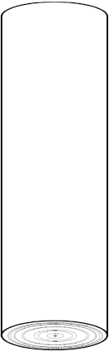

2018ミシガン

日本語弁論大会

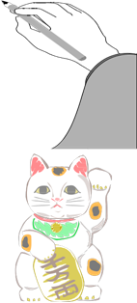

**2018 Michigan Japanese Language Speech Contest**



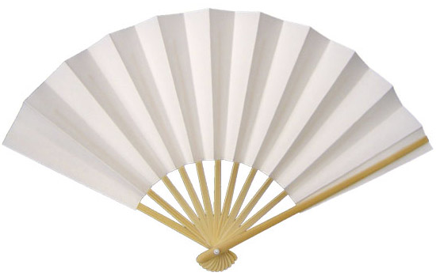

If you **love** Japanese, a real challenge, and

the chance to win **great** prizes, join us for the

**Michigan 2018 Japanese Language Speech Contest**.

Applications and information are available through your language instructor or online at

<http://www.detroit.us.emb-japan.go.jp/itprtop_en/index.html.>

The event will be on

**Saturday, February 24th, 2018**

Deadline for Entries

from 1:00PM

January 26, 2018

**at the Novi Civic Center**

**SPONSORS**

**JAPANESE TEACHERS ASSOCIATION OF MICHIGAN**

**JAPAN BUSINESS SOCIETY OF DETROIT**

**JAPAN AMERICA SOCIETY OF MICHIGAN AND SOUTHWESTERN ONTARIO**

*The Consulate General of Japan in Detroit is pleased to announce that applications are now being accepted for the 2018 Michigan Japanese Language Speech Contest. The competition, now in its 23nd consecutive year, was established to encourage students to experience the power of foreign language communication, increase the desire for Japanese language students to improve their skills and understanding, and strengthen the bond of friendship between the United States and Japan through their efforts. We welcome your participation.*

**DATE** Saturday, February 24, 2018  
 from 1:00PM

**LOCATION** Novi Civic Center

45175 W 10 Mile Rd, Novi, MI 48375

**CATEGORIES** High School  
 University

**DEADLINE** **5PM – January 26, 2018**

Entry form in word document; word document of English translation of speech, word document of speech text in Japanese; and audio of speech (.mp3 only and under 10 MB) **Don’t forget your name in English and Japanese!**

**CO-SPONSORS** Japanese Teachers Association of Michigan

Japan Business Society of Detroit  
 Japan America Society of Michigan & Southwest Ontario

**IN COOPERATION WITH** City of Novi

**FORMS** Additional forms and criteria may be downloaded from our

website.

*For questions please contact Mr. Adam Wolf at the Consulate office   
(313-567-0120 ext. 226, or Adam.wolf@dt.mofa.go.jp)*

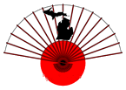

I. Japanese

a. Pronunciation

５点：The speaker spoke Japanese with native

fluency.

４点：The speaker had near native Japanese.

３点：The speaker mixed their native language’s

pronunciation with Japanese several times.

２点：The influence of the speaker’s native

language’s pronunciation made it difficult to

understand.

　１点：The pronunciation of the Japanese made it

impossible to understand.

b. Accuracy（Grammar, Vocabulary）

５点：The vocabulary and grammar used in the speech

seemed like native level Japanese.

　４点：There were occasional grammar and vocabulary

mistakes.

　３点：The speaker made many grammar and

vocabulary mistakes.

　２点：The speaker’s grammar and vocabulary were

very hard to understand, but intelligible.

　１点：The speaker’s grammar and vocabulary

were completely incorrect

II.　Presentation

a. Engagement with Audience

５点：The speaker was able to deliver their speech

without looking at their note cards at all.

４点：The speaker was able to deliver their speech

while rarely looking at their note cards.

３点：The speaker engaged the audience, and looked

at their note cards equally.

２点：The speaker engaged the audience occasionally.

１点：The speaker only read from their note cards.

b. Intonation and Clarity

５点：The speaker was able to deliver their speech

fluidly without breaks.

４点：The speaker was able to deliver their speech

with one or two mistakes or word repetitions.

３点：The speaker was able to deliver their speech but

made several mistakes or word repetitions.

２点：The speaker made many mistakes that broke up

their speech.

１点：The speaker did not complete their speech.

III．Content

a. Content A（Interesting, Original）

５点：The content was very original and interesting.

４点：The content was interesting and innovative, but

not unheard of.

３点：The content was somewhat interesting, but not

very original.

２点：The content had potential, but was not very

meaningful.

１点：The content was not original or interesting.

b. Content B（Structure）

５点：The piece was well structured and had a clear

narrative.

４点：The piece was structured well, but there were

one or two parts that seemed choppy or

disconnected.

３点：The piece had okay structure, but lacked some

major connection from one section to the next.

２点：The piece was poorly structured, but was

understandable.

１点：There was no structure and the piece was not

clear.

IV．Question-and-Answer Session

(University only)

３点：The speaker replied with native fluency.

２点：The speaker was able to effectively answer

questions.

１点：The speaker was able to understand questions,

but the answers were incomplete.

０点：The speaker did not understand what was

asked.

**IF TIME RUNS OVER, UP TO -5 POINTS MAY BE ASSESED**